**UNBREAKABLE STRENGTH: A CASE STUDY OF HONOURABLE MORADEYO ABIDOYE.** SPECIAL ADVISER TO THE GOVERNOR.

Getting support for women in politics is said to be a herculean job, even more tedious than that. As it is always said that politics is a game of number, which most women lack due to stigmatization, lack of resources, abuse, societal pressures, religious and cultural norms and so much more. Politics of nowadays is seen as “men’s game” only, women have been relegated to the “other room”, not only that, they also make sure that women lack support of other women by brainwashing them with their ideas. Since "all their education ends in the kitchen," women are not given the chance to take on leadership roles or receive political office, instead they are viewed as mothers and caregivers. The lack of appropriate awareness, sensitization, and education have made all of these possible, which is why appropriate action is required.

Given the aforementioned issues that women face, the Omu-Aran Women Forum with the support from ActionAid and funding by Global Affairs Canada spearheaded a rising initiative to support more women in their quest for public office. This was accomplished by awareness raising, conferences, workshops, advocacies, media engagement, leadership development, and empowerment. Honorable Moradeyo Abidoye, a retired teacher is a native of Rore in Irepodun Local Government Area. She joined politics in the year 1989 when democracy returned to the Country. Honourable Moradeyo vied for political position during governor Lawal before his death and Governor Bukola Saraki which did not yield positive result. She was subjected to a great deal of discrimination, harassment, and sexism because she is a woman, and as a result, she failed multiple times to get elective posts. She vied for elective position in 2015 and was not nominated at the primary level, she made her intension known at the local government level too and also failed. She has been an active member of Omu-Aran Women Forum and was elected as the forum’s Public Relation Officer during our Annual General Meeting in the year 2020. Since her appointment she has contributed well in sensitizing more women on the need to be active politician.

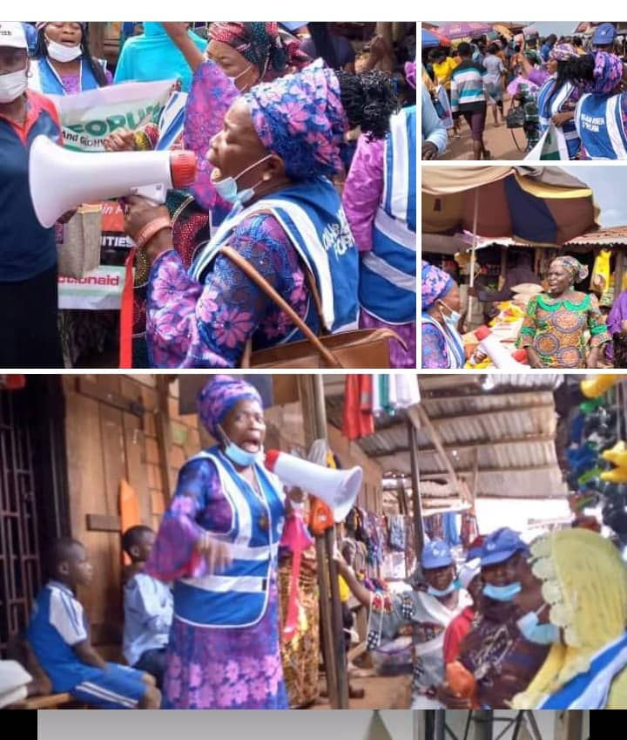

Figure : HON. MORADEYO ABIDOYE DURING SENSITISATION OF WOMEN ON POLITICAL PARTICIPATION

Honourable Moradeyo in appreciation of her roles in women political participation across all different levels was appointed as a first assembly member by a Change Agent International, a non –Governmental Organization to further support her political aspiration and desires. Omu-Aran Women Forum was fully present and supported her at her inauguration in Ilorin, Kwara

State. In the 2023 election, she presented herself to contest for the house of assembly and was quite supported by members of Omu-Aran Women Forum who stood by her throughout the process but was prevailed upon to step down for a male counterpart. She was not discouraged by this has she enjoyed strong backing of OWF. She was also arrested during the last election and detained for some days until after the election.

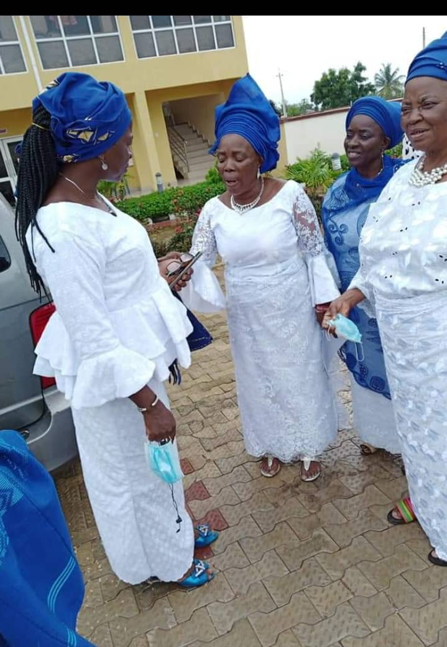

Figure 3. OWF members at the inauguration of Hon, Abidoye as Assembly member.

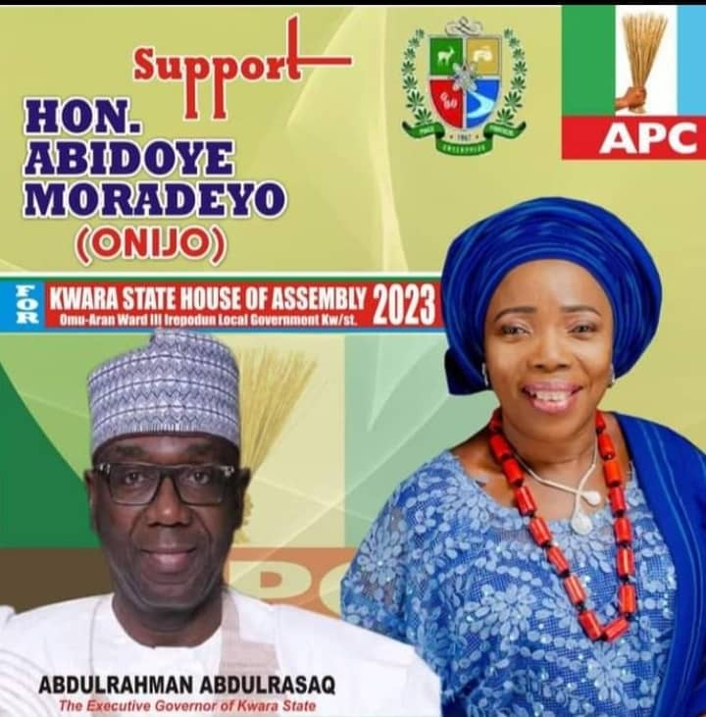

Figure : Hon. Abidoye Moradeyo as a contestant

To crown her unrelenting efforts, she was given an appointive position as the Special Adviser on sustainable development goals by His Excellency, Mallam AbdulRahman AbdulRasaq the present Executive Governor of Kwara State. Hon. Moradeyo Abidoye is now a role model to other women in our communities following her journey in politics so far.

q on SDG.